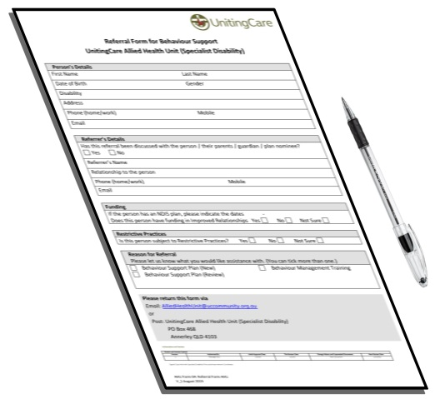

Referral Form for Behaviour Support

Uniting Care - Allied Health Unit (Specialist Disability)

Your Details

Your name? Male or Female? Date of birth?

Disability?

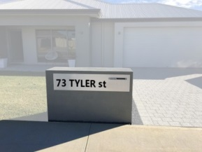
Home address? Phone number?
00

Email address?

Has this referral been explained to you?

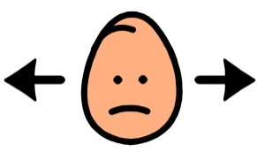
I don’t know
No
Yes

Referrer’s Details
Referrer’s name? Their relationship to you?

Referrer’s phone number? Email?

Funding
00
If you have an NDIS plan, what are your plan dates?

Do you have funding in Improved Relationships?

I don’t know
No
Yes

Restrictive Practices
Do you have Restrictive Practices?
No
Yes
I don’t know

Reason for Referral
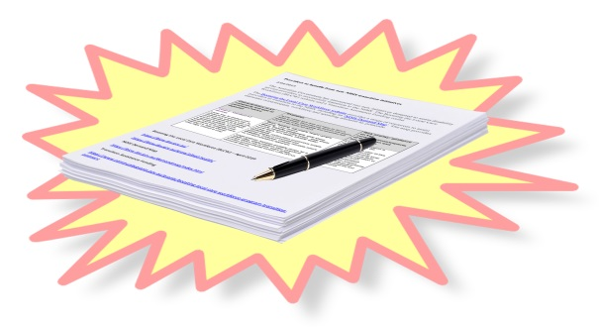
Behaviour Support Plan (new) Behaviour Management Training

Behaviour Support Plan (review)

Post

Email

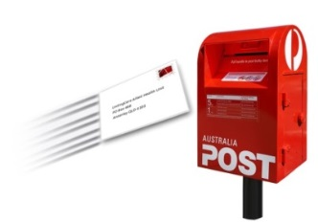
UnitingCare Allied Health Unit
PO Box 468
Annerley QLD 4103

AlliedHealthUnit@uccommunity.org.au

Authorisation and Contacts
Review and Version Control
Version | Authorised By | Initial Approval | This Review Date | Change History | Next Review
1 | General Manager  Disability Services | April 2019 | 16/4/2019 | New Document | 16/4/2021
Signed Copy held with Continuous Improvement Disability

