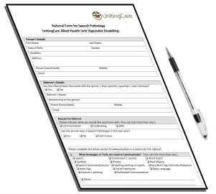 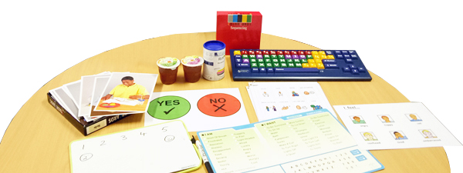

**Referral Form for Speech Pathology**

**Uniting Care - Allied Health Unit (Specialist Disability)**

**Your Details**

  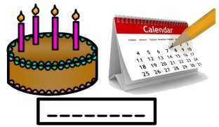

Your name? Male or Female? Date of birth?

|  |  |  |
| --- | --- | --- |
|  |  |  |



Disability?

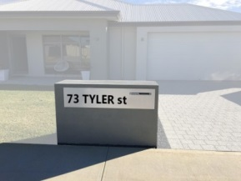 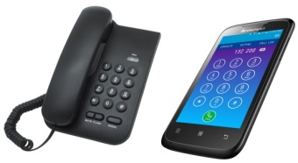

Home address? Phone number?

|  |  |  |
| --- | --- | --- |
|  |  |  |
|  |
|  |
|  |
|  |

00



Email address?

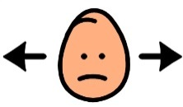

yes

Has this referral been explained to you?



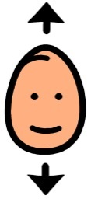 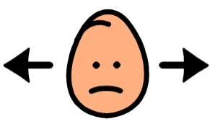 

**Referrer’s Details**

 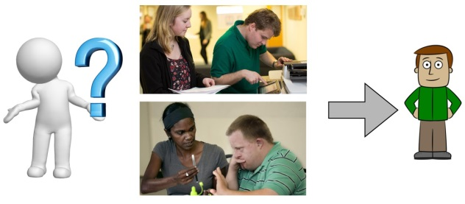

Referrer’s name? Their relationship to you?

|  |  |  |
| --- | --- | --- |
|  |  |  |

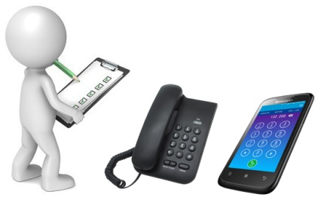 

Referrer’s phone number? Email?

|  |  |  |
| --- | --- | --- |
|  |  |  |

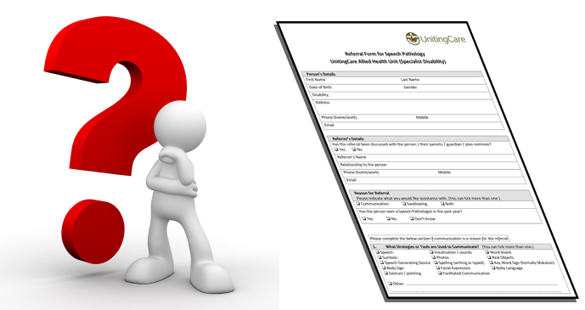

**Reason for the Referral**

 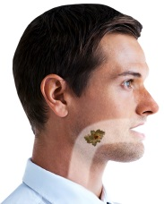  

**+**

CommunicationSwallowingBoth

****Have you seen a Speech Pathologist in the past year?

 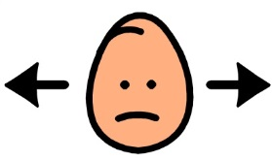 

yes

no

I don’t know



**How do you communicate?**

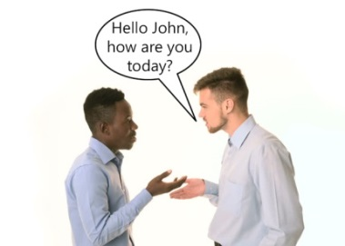 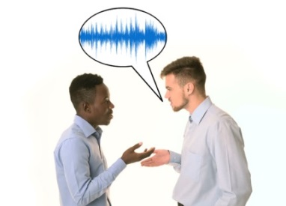 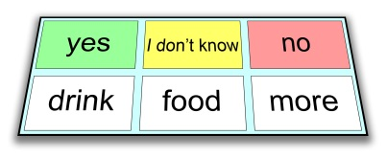

SpeechVocalisations / soundsWord board

 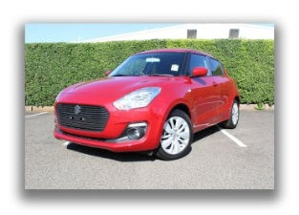 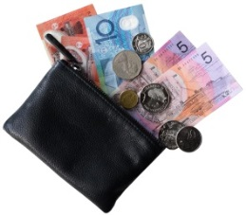

SymbolsPhotos Real objects

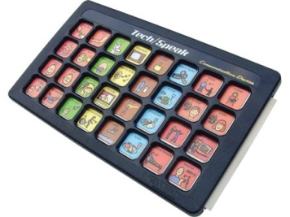 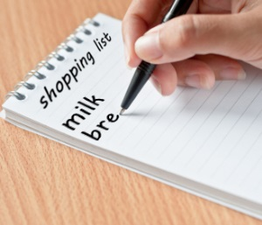 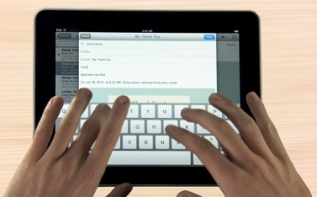

Speech Generating Device Spelling (writing or typed)

 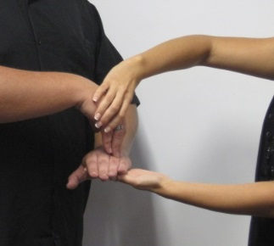

Key Word Sign (formerly Makaton)Body Sign

** **

Facial expressionBody language

 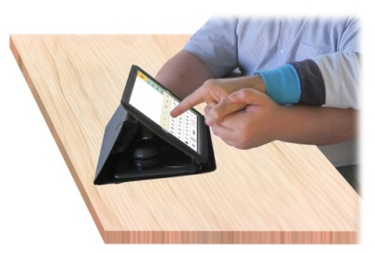

Gesture / pointingFacilitated Communication

** **

Other

|  |
| --- |
|  |



What happens if there is a communication breakdown?

How do you express “yes” or positive feelings?



happy

yes

How do you express “no” or negative feelings?



sad

no

Are there any obvious changes in communication skills recently?

 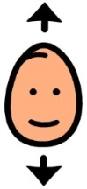 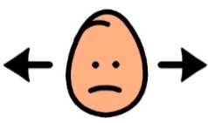

no

yes

Why?



|  |
| --- |
|  |

  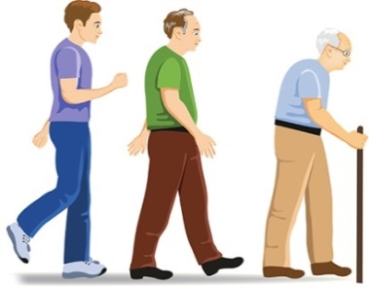

Trauma Ill healthAgeing

** **

Medication Unknown



Other:

|  |
| --- |
|  |

**Summary of communication with others**



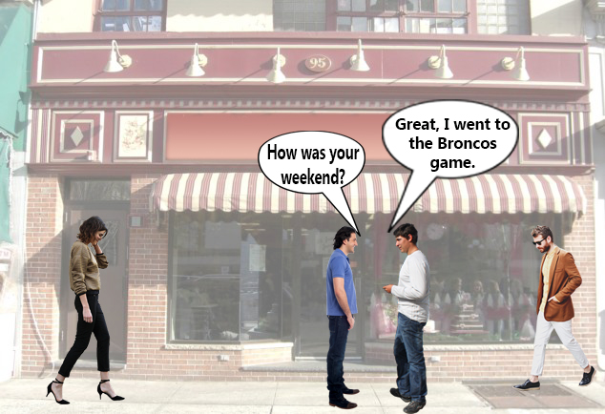Are you understood by people in the community?

 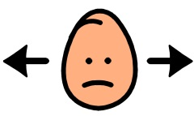

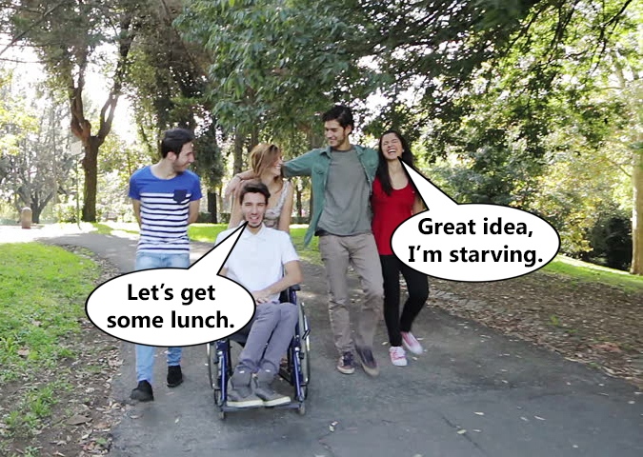  
Are you understood by familiar people?

** **

Do you have communication breakdowns with new people?

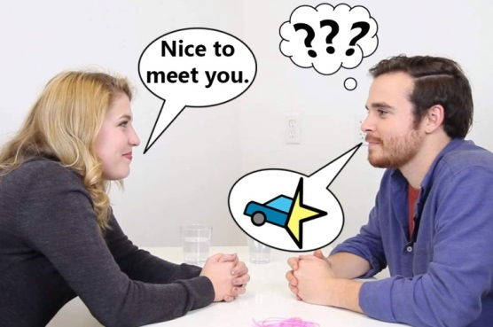

** **

Does communication work well with only one or two people?

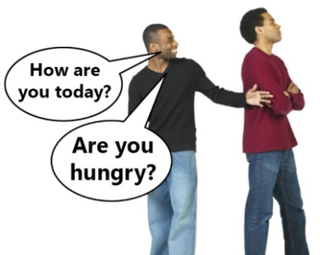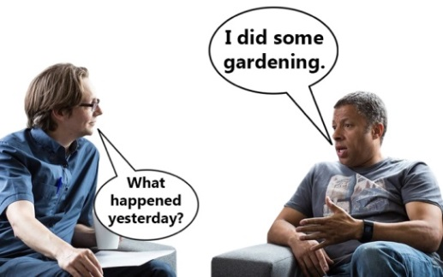   
 ** **

Do you have very few communication strategies?

**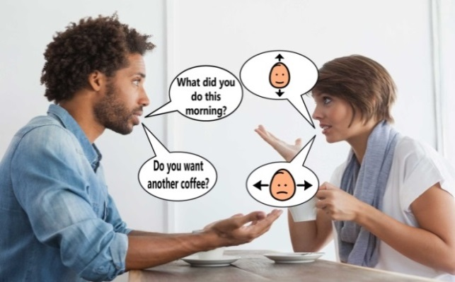  
  **

**Post**

**Email**

 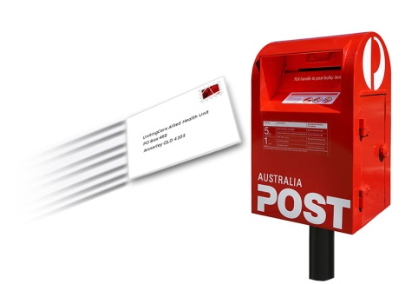

*UnitingCare Allied Health Unit*

*PO Box 468*

*Annerley QLD 4103*

[*AlliedHealthUnit@uccommunity.org.au*](mailto:AlliedHealthUnit@uccommunity.org.au)

**Authorisation and Contacts**

|  |  |  |  |  |  |
| --- | --- | --- | --- | --- | --- |
| **Review and Version Control** | | | | | |
| **Version** | **Authorised By** | **Initial Approval** | **This Review Date** | **Change History** | **Next Review** |
| 1 | General Manager  Disability Services | April 2019 | 16/4/2019 | New Document | 16/4//2021 |

Signed Copy held with Continuous Improvement Disability