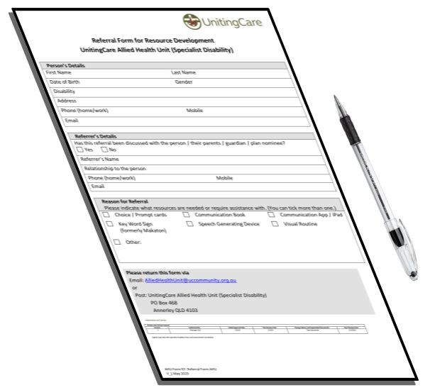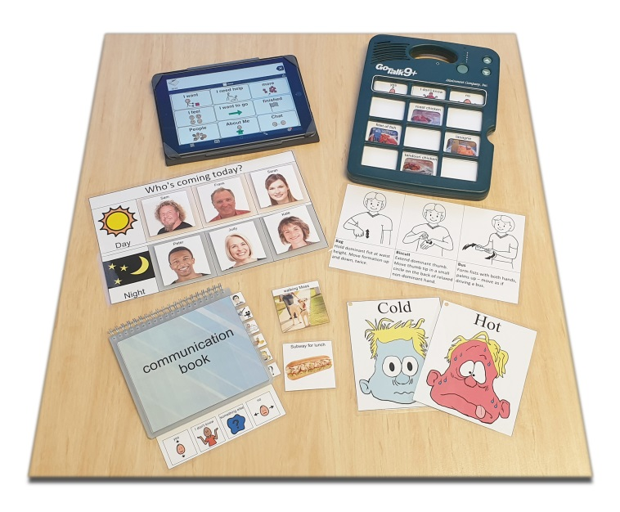

Referral Form for Resource Development

Uniting Care - Allied Health Unit (Specialist Disability)

Your Details

Your name? Male or Female? Date of birth?

Disability?

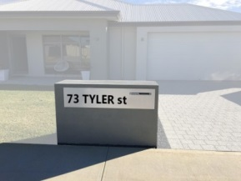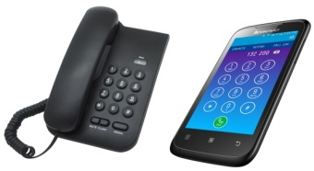
Home address? Phone number?
00

Email address?
If you have an NDIS plan, what are your plan dates?
00

Has this referral been explained to you?

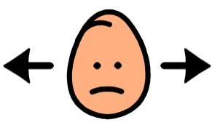
I don’t know
No
Yes

Referrer’s Details
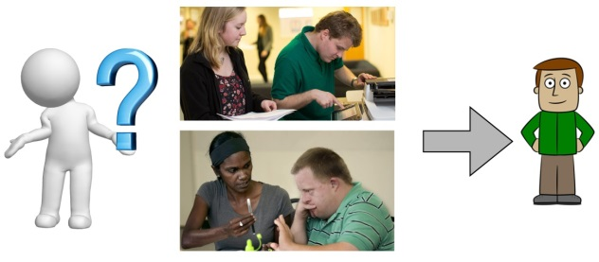
Referrer’s name? Their relationship to you?

Referrer’s phone number? Email?

Reason for the Referral
Key Word Sign (formerly Makaton) Photo / symbol cards

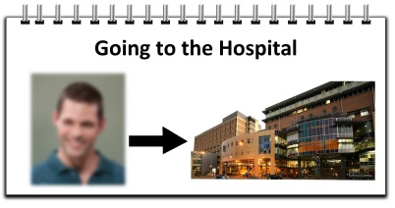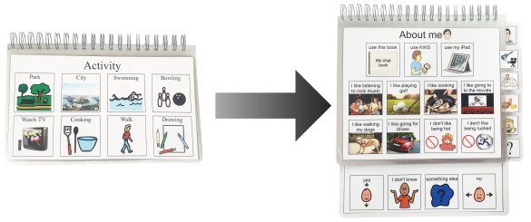
Social / digital story Updating communication book

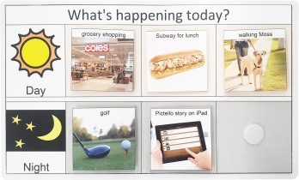
Visual aid/s (visual routine) Other

What do you need?

Post

Email

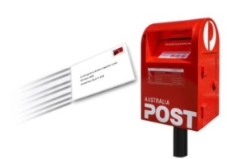
UnitingCare Allied Health Unit
PO Box 468
Annerley QLD 4103

AlliedHealthUnit@uccommunity.org.au
Authorisation and Contacts
Review and Version Control
Version | Authorised By | Initial Approval | This Review Date | Change History | Next Review
1 | General Manager  Disability Services | April 2019 | 16/4/2019 | New Document | 16/4/2021
Signed Copy held with Continuous Improvement Disability

